

24ADC001- BUSINESS INTELLIGENCE

PRIYA DHARSHINI R
24BAD092
--------------------------------------------------

2026-2027
LAB RECORD

DEPARTMENT OF ARTIFICIAL
INTELLIGENCE AND DATA SCIENCE

INDEX
Expt. No | Title of the Experiment | Page No | Total  Marks | Faculty Signature
1. | Explore the interface and basic features of the BI tool
2. | Load and visualize a sample dataset.
3. | Import a dataset into the BI tool. And Cleanse data by handling missing values, outliers, and inconsistencies.
4. | Transform data to suit BI reporting requirements and Design a dashboard with key performance indicators (KPIs).
5. | Develop interactive dashboards for dynamic data exploration.
6. | Integrate data from various sources for comprehensive analysis
7. | Implement advanced chart types (treemaps, heatmaps, etc.).
8. | Apply BI tools for forecasting and predictive analytics.

Average marks Faculty Signature

EXPT NO:1 | EXPLORE THE INTERFACE AND BASIC FEATURES OF BI Tool
DATE: 10.07.2026

PRE-LAB QUESTIONS (PROVIDE BRIEF ANSWERS TO THE FOLLOWING QUESTIONS)

- What is the purpose of Business Intelligence (BI) tools like Tableau and Power BI?

Business Intelligence (BI) tools like Tableau and Power BI help users collect, analyze, and visualize data in a meaningful way. They convert raw data into charts, graphs, and dashboards that are easy to understand. These tools help identify trends, monitor performance, and support better business decisions.

- List any three common data sources that Tableau and Power BI can connect to.
Some common data sources are:

Tableau and Power BI can connect to a variety of data sources. Three commonly used sources are Microsoft Excel, CSV files, and SQL Server databases. They can also connect to cloud services and online databases for real-time data analy

- What is a dashboard in BI, and how is it different from a single chart?
A dashboard is a collection of multiple charts, tables, and KPIs displayed on a single screen. It provides a complete view of the data in one place. A single chart shows only one type of information, whereas a dashboard combines different visualizations for better analysis and decision-making.
- Define the following terms:

  - Visualization
Visualization is the process of presenting data in the form of charts, graphs, maps, or tables. It makes complex information easier to understand and interpret. Good visualizations help users identify patterns, trends, and relationships quickly.
  - KPI
A KPI is a measurable value that shows how well a business or project is achieving its objectives. It is used to track performance over time and measure success. Examples include sales revenue, profit, and customer satisfaction.

  - Data Filter
A data filter is used to display only the required data based on selected conditions. It helps users focus on relevant information while hiding unnecessary data. Filters make analysis faster and more meaningful.

- Why is it important to clean and transform data before visualization?

Cleaning and transforming data improves its quality before creating visualizations. It removes duplicate records, corrects errors, and handles missing values. Well-prepared data produces accurate charts and helps users make reliable decisions based on correct information.

- What kind of chart would you use to analyze stock price trends over time?

A Line Chart is the best choice for analyzing stock price trends over time. It clearly shows how prices increase or decrease across different dates. This makes it easier to identify patterns, compare performance, and observe long-term trends.

- Explain the role of slicers in Power BI and filters in Tableau.

Slicers in Power BI and filters in Tableau allow users to interact with the data by selecting specific values or categories. They help display only the information needed for analysis. This makes dashboards more flexible, interactive, and user-friendly.

- What does a calculated field or measure do in BI tools?
A calculated field or measure is used to perform calculations using existing data. It can calculate totals, averages, percentages, or custom formulas without changing the original dataset. This helps users create meaningful insights and improve data analysis.

- What are the advantages of using interactive dashboards for financial data analysis?
Interactive dashboards make it easy to monitor financial performance and compare important business metrics. Users can filter data, drill down into details, and explore trends in real time. This helps organizations make faster and more informed financial decisions.

- Which function would you use to find the absolute difference between predicted and actual stock prices?
The ABS() function is used to calculate the absolute difference between predicted and actual stock prices. It always returns a positive value regardless of the direction of the difference. This makes it useful for measuring prediction errors and evaluating model accuracy.

IN-LAB EXERCISE:
Objective:
To understand the basic interface, data import process, and fundamental visualization capabilities of Tableau and Power BI using a stock prediction dataset, and to explore their usefulness in analyzing financial data.

Tools Required:
- Tableau Public / Tableau Desktop
- Power BI Desktop
- Sample Dataset (CSV/Excel) containing:
Date, Stock Name, Open, Close, High, Low, Volume, Predicted Price

Exercise Steps:
Part 1: Working with Tableau
- Launch Tableau and connect to the stock prediction dataset.
- Explore the Interface: o Understand components like Data Pane, Sheets, Marks Card, and Dashboards.
- Create Basic Visualizations:
  - Line Chart: Show Close Price over time. o Scatter Plot: Plot Volume vs. Predicted Price.
  - Highlight Table: Display Predicted Price by stock.
- Apply Filters:
  - Add filters for Stock Name and Date Range.
- Create Calculated Field: o Calculate prediction error as |Predicted - Close|.
- Design a Basic Dashboard:
  - Combine your charts into one interactive dashboard.

Part 2: Working with Power BI
- Open Power BI Desktop and import the same dataset.
- Explore the Interface: o Familiarize with Fields Pane, Visualizations Pane, Report View, Data View.
- Create Basic Visualizations:
  - Line Chart: Trend of Close Price over time.
  - Bar Chart: Compare Predicted Price vs. Close Price.
  - Card (KPI): Display average prediction error.
- Use Filters and Slicers:
  - Filter data based on Stock Name and Date.
- Create a Simple Measure using DAX:
  - Example: Prediction Error = ABS(Predicted - Close)
- Build a Report Page:
  - Arrange visuals in a single interactive page.

PowerBI

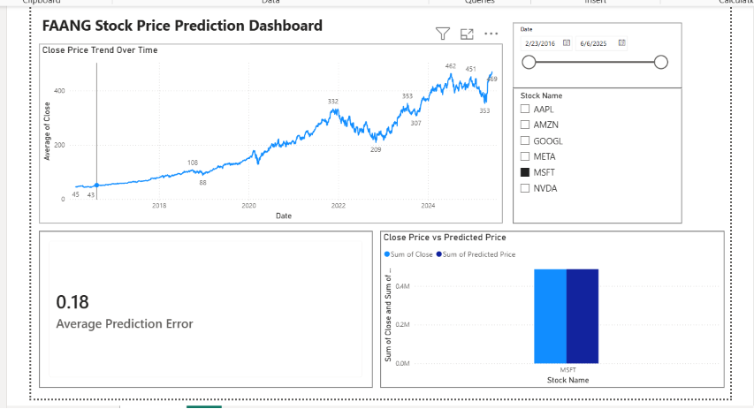

Tableau

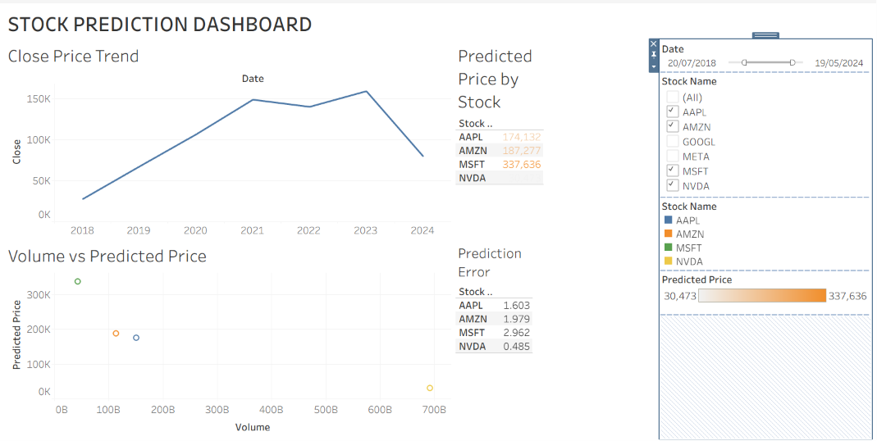

POST-LAB QUESTIONS (PROVIDE BRIEF ANSWERS TO THE FOLLOWING QUESTIONS)
- Describe your experience with the Tableau interface. What components did you interact with?

Using Tableau was a smooth and interactive experience. I worked with the Data Pane to access the dataset, the Sheets to create visualizations, and the Marks Card to customize colors and labels. I also used the Dashboard section to combine multiple charts into a single interactive view. The interface was easy to understand after exploring its features.

- How did you import the dataset into Tableau and Power BI?

In Tableau, I clicked Connect, selected the CSV/Excel file, and loaded the dataset into the workspace. In Power BI, I used the Get Data option to import the same dataset. Both tools automatically detected the columns and data types. The import process was quick and straightforward.

- What types of visualizations did you create in both tools? List at least two per tool.

In Tableau, I created a Line Chart to show the closing price over time and a Scatter Plot to compare volume with predicted price. I also created a Highlight Table for predicted prices. In Power BI, I created a Line Chart, a Bar Chart, and a KPI Card to display the average prediction error. These visuals helped in understanding stock performance.

- How did you calculate the prediction error, and how was it displayed in your dashboard?

I calculated the prediction error by finding the absolute difference between the Predicted Price and the Close Price using the formula ABS(Predicted - Close). In Tableau, I created it as a calculated field. In Power BI, I used a DAX measure for the same calculation. The result was displayed using a KPI card and included in the dashboard for quick analysis.

- Which filtering or slicing techniques did you apply, and what insights did they reveal?

I applied filters and slicers for Stock Name and Date in both Tableau and Power BI. These filters helped me focus on specific stocks and time periods. It became easier to observe price trends and compare prediction accuracy. The filters made the dashboard more interactive and user-friendly.

- Compare the process of creating a line chart in Tableau vs. Power BI. What differences did you notice?

In Tableau, I created the line chart by dragging the Date and Close Price fields onto the rows and columns. In Power BI, I selected the Line Chart visual first and then added the required fields. Tableau offered more flexibility in customization, while Power BI was easier for beginners. Both tools produced clear and effective visualizations.

- How did you organize the dashboard in Tableau and Power BI? What key elements did you include?

I arranged the charts neatly so that all important information was visible on one page. The dashboard included a Line Chart, Scatter Plot/Bar Chart, Prediction Error KPI, and filters for stock and date. This layout made it easy to compare different aspects of the data. The interactive design improved the overall user experience.

- Which tool (Tableau or Power BI) did you find more user-friendly for financial data visualization, and why?

I found Power BI more user-friendly because its interface was simple and easy to navigate. Creating charts, cards, and filters required fewer steps compared to Tableau. It also provided useful DAX functions for calculations like prediction error. Overall, it was convenient for building financial dashboards.

- What challenges did you face while creating visualizations or dashboards?

Initially, I had some difficulty selecting the correct fields and choosing the appropriate chart types. I also faced small issues while creating calculated fields and arranging the dashboard layout. Understanding filters and formatting options took some practice. After experimenting with the tools, I was able to complete the dashboard successfully.

- How can the knowledge gained from this lab be applied to real-world financial data analysis?

This lab helped me understand how visualization tools can simplify financial data analysis. It showed how to monitor stock prices, compare predictions with actual values, and identify trends. Interactive dashboards can support faster and better decision-making. These skills are valuable for financial analysts, investors, and business professionals.

ASSESSMENT

Description |  | Max Marks | Marks Awarded
Pre Lab Exercise |  | 5
In Lab Exercise |  | 10
Post Lab Exercise |  | 5
Viva |  | 10
 | Total | 30
 |  | Faculty Signature

